**ASME Journals Digital Submission Tool**

**Final Submission**

**Preparing and Submitting Your Final Digital Files**

These author guidelines contain information to assist the user in preparing and submitting the final versions of technical and non-technical works that have been accepted for publication in an ASME journal. Authors will receive notification of acceptance via e-mail and can submit final materials when so noted in the **Options** section of the **Author Status** page.

The final version of an author’s work should be just that, so authors are strongly advised to ensure the accuracy and integrity of all elements prior to submittal of these final materials to the site. For information on writing and styling, or for additional details, please refer to the[Guidelines for Journal Submission](http://journaltool.asme.org/Help/AuthorHelp/WebHelp/Guidelines/Getting_Started.htm).

In addition to the provision of these final materials, each technical work must be accompanied by a completed and properly executed transfer of copyright form. Please see more details under [Copyright Transfer](http://journaltool.asme.org/Help/AuthorHelp/WebHelp/Guidelines/Copyright_Transfer.htm).

**Technical Submissions**

The final versions of accepted papers and technical briefs will be submitted/uploaded to the site as follows and in the order shown:

* PDF file of the complete paper file
* Text-only file(s) in native format (Word, LaTex, or FrameMaker)
* Graphics file(s) **(one file for each figure)** in TIFF or EPS format

See details below.

**I. COMPLETE PAPER (PDF FILE)**

The final version of the complete paper must be prepared as a double-spaced, single-column manuscript for legibility and readability. This complete paper should contain all elements of the paper: text, tables, graphics (and captions), references, etc. **The final complete version must be submitted in PDF format**.

**Guidelines for Preparing Complete Paper (“Web-Ready”)**

* The full contents of the paper must be submitted in the PDF file.
* The PDF file must include a listing of figure and table captions.
* The PDF file should have footers on each page. The footer should contain the assigned paper number, the corresponding author’s last name, and the page number.

**Submitting the Complete Paper**

* The PDF file ("web ready") must be submitted first, followed by the native file ("print ready") and then graphics.
* All files must be properly named with the journal paper number and the proper extension (.pdf).

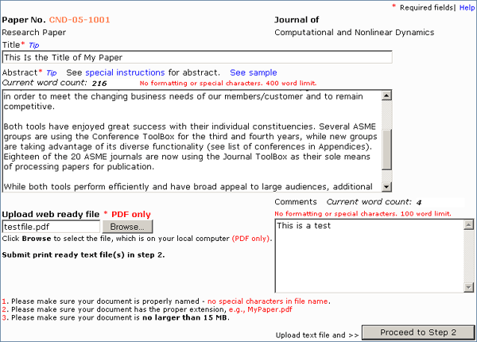

**II. TEXT-ONLY FILE(S)**

The final version of the text-only file(s), including tables but without figures, must be prepared as a double-spaced, single-column manuscript for legibility and readability. A list of figure and table captions should be placed at the end of the file. **The final text version must be submitted in native format**. The site is currently accepting Word, LaTeX, and FrameMaker.

**NOTE:** The PDF file should contain all elements of the paper: text, tables, graphics, references, etc. The native text file should contain text only. (This file can include tables; tables can also be uploaded separately as graphic files.)

**Guidelines for Preparing Text ("Print-Ready")**

* + **The native text file should contain text only, including references** (and can include tables). No figures.
  + The native text file must include a listing of figure and table captions at the end of the file.
  + If submitting a Word document, all math must be created using the Equation Editor supplied with Microsoft Word.
  + If submitting a Word document, all tables must be created using the Table utility provided with Microsoft Word.
  + The native text file should have footers on each page. The footer should contain the assigned paper number, the corresponding author’s last name, and the page number.
  + Styling of headings and other text elements is necessary to enhance organization and readability. Authors should use boldface, italic, etc. as appropriate. In addition, inclusion of boldface, italic, and roman is necessary to indicate math and other special characters.

**LaTex Submissions**

* + Download  [LaTex template](javascript:%20openWindow('ASME_JournalTemplate.tex');) and [BibTex reference style file](javascript:%20openWindow('asme_journals.bst');) for submitting final files.
  + A single .tex file should be submitted.
  + File names for figures: use "figure" or "fig" followed immediately by a number. There may be an underscore between fig/figure and the number. A letter may follow the number if a multi-part figure.

**Submitting Text**

* + The text file(s) (“print ready”) must be submitted (uploaded) second (after the PDF file of the complete paper and before any graphics files).
  + All files must be properly named with the journal paper number and the proper extension (e.g., doc, .tex, .txt, .frm).

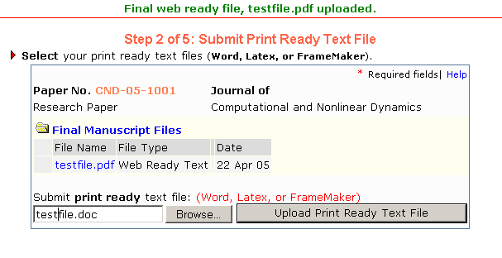

**III.****PREPARING GRAPHICS**

**TIFF or EPS only**

* To be usable, the TIFF or EPS files need to be created using the ‘save as’ function and then choosing ‘TIFF’ or ‘EPS’ from within the application used to create the graphic. Specific requirements below.
* Prior to submission, figures can be uploaded to the following on-line service and tested for usability: [http://dx.sheridan.com/](http://dx.sheridan.com). The site also contains additional information on creating digital files.
* Always print each graphic file as a proof before submitting.

**Multi-Part Figures**

* Whenever possible, multi-part figures should be submitted as a single file.

**File Naming**

* For auto-processing of figures, the file name must include "figure" or "fig" followed immediately by a number. There may be an underscore between fig/figure and the number. A letter may follow the number if a multi-part figure.

**TIFF Format**

* Use for bitmap graphics
* Set resolution to 600 dpi for line art, 264 dpi for halftones (photographs), and 600 dpi for combinations
* If necessary, set color mode to CMYK (Cyan, Magenta, Yellow, Black)

**EPS Format**

* Use for vector graphics
* Set resolution to 600 dpi
* If necessary, set color mode to RGB-encoded at 8 bits/channel

**Sizing**

* Graphics should be the same size as they should appear in journal.
* Single Column Width: 8 cm (3.25 in., 20 picas)
* Double Column Width: 16 cm (6.5 in., 40 picas)
* Maximum Length: 23 cm (9.5 in., 57 picas)]

**Cropping**

* Remove any extra white space from around the image.
* Do not include borders.

**Color Graphics**

* Color graphics will be used in the on-line version of the journal if supplied.
* All graphics will appear in black and white in the print version of the journal unless color costs are paid, see [Publication Charges](http://journaltool.asme.org/Help/AuthorHelp/WebHelp/Guidelines/Publication_Charges.htm).
* Color figures can reproduce very poorly in black-and-white with necessary information being lost: prior to submission, print color figure files on a black-and-white laser printer to see if they will reproduce well in the print edition of the journal.

**Fonts**

* True Type: Arial, Helvetica, Times New Roman, Courier
* Adobe fonts
* Embed in graphic
* Font Size: 6 pt or larger. WATCH: If figure is reduced, font can become illegible.

**Miscellaneous**

* Line weights should be  0.5 pt - 1.5 pt in thickness. WATCH: line weights below 0.5 points will disappear.
* Upload files in order.
* Whenever possible, each figure should be one file and not submitted as multiple parts.
* A graphic file cannot exceed 15 MB.

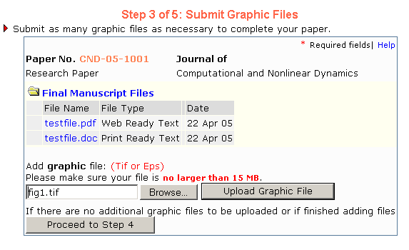

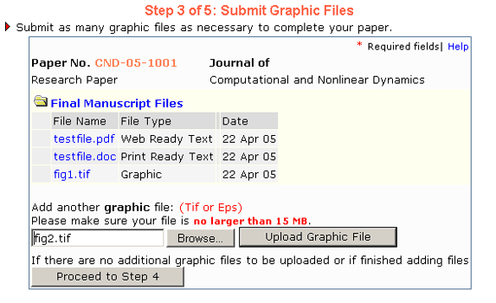

**NOTES:**

* To update your final paper, choose the link, “Resubmit” under the “Options” box. Browse for your updated paper, and choose “Upload File”. Any new files submitted will overwrite those uploaded previously.
* To update graphics files, choose the link, “Resubmit” under the “Options” box. Browse for your graphics files and choose “Upload File”. Any new files submitted will overwrite those uploaded previously. If you wish to delete a graphic, choose the “Remove” link.
* To update your final paper title and/or abstract, choose the button “Update Title-Abstract”. Make the necessary changes and choose “Update” to submit them.
* To update author information, choose the button “Update Authors”. Make the necessary changes by choosing the “Update” or “Remove” links next to each author name. You may also adjust the publication order by choosing “Update Roles & Order”.  If you need to add an additional author, choose the button “Add Author”.
* To submit a Copyright (1903) Form, choose the button, “Submit Copyright”. Download the form (in PDF format) and send it to the necessary recipient.
* LaTex users: At this time, we are only accepting the .tex file type.

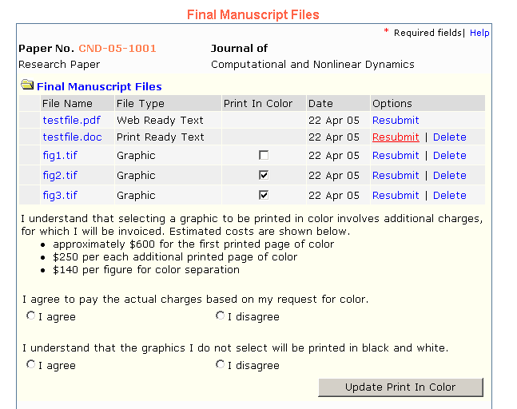

**Non-Technical Submissions**

The final versions of non-technical submissions (discussions and closures, editorials, book and software reviews, announcements, etc.) need to be prepared as noted below.

**FORMAT**

* Discussions and closures, editorials, and other text-oriented submissions must be submitted in both PDF and native formats. Word, LaTeX and FrameMaker are currently accepted.
* Announcements (including Calls for Papers) must be submitted in PDF format.
* Book and software reviews must be submitted as noted above under Technical Submissions if these contain both text and graphics.
* Special sections such as the Solar Scenery or Heat Transfer Gallery items should be submitted in PDF format and as individual graphic files.

**Submitting Text**

* + The PDF file ("web ready") must be submitted first, followed by the native file ("print ready")] and then graphics.
  + All files must be properly named with the journal paper number and the proper extension (e.g., doc, .tex, .txt, .frm).

**Submitting Graphics**

* + Refer to the [Guidelines for Technical Submissions](http://journaltool.asme.org/Help/AuthorHelp/WebHelp/Submissions/Submitting_Your_Final_Digital_Files.htm#Guidelines) (above).

**NOTES:**

* To update your final paper, choose the link, “Resubmit” under the “Options” box. Browse for your updated paper, and choose “Upload File”. Any new files submitted will overwrite those uploaded previously.
* To update graphics files, choose the link, “Resubmit” under the “Options” box. Browse for your graphics files and choose “Upload File”. Any new files submitted will overwrite those uploaded previously. If you wish to delete a graphic, choose the “Remove” link.
* To update your final paper title and/or abstract, choose the button “Update Title-Abstract”. Make the necessary changes and choose “Update” to submit them.
* To update author information, choose the button “Update Authors”. Make the necessary changes by choosing the “Update” or “Remove” links next to each author name. You may also adjust the publication order by choosing “Update Roles & Order”.  If you need to add an additional author, choose the button “Add Author”.
* To submit a Copyright (1903) Form, choose the button, “Submit Copyright”. Download the form (in PDF format) and send it to the necessary recipient.
* LaTex users: At this time, we are only accepting the .tex file type.